**Natural Learning Processing: DATS 6312**

Individual Report

**Sarcasm Detection Project**

Instructor: Amir Jafari

Presented By Group 6:

Shikha Sharma

**Date: 11th Dec 2023**

**Table of Contents**

**1. Introduction** 3

**2. Dataset Description** 3

**3. Description of Individual Work** 4

**3.1 Proposed Algorithms** 5

**4. NLP Algorithms** 6

**4.1. Rule-based Algorithms** 6

**4.1.1 Naive Bayes** 6

**4.1.2. Logistic Regression** 7

**4.2 Pretrained NLP (Transformers Based Networks)** 7

**4.2.1 BERT, RoBERTa** 7

**4.3. Evaluation metrics** 8

**4.4. Interpretability and Explainability** 9

**4.4.1. LIME** 9

**5. Results** 10

**6. Summary and Conclusion** 23

**7 Percentage of code** 24

**Reference** 24

# **1. Introduction**

The challenge of detecting sarcasm in textual content is a fascinating and complex problem in the realm of Natural Language Processing (NLP). Our project aims to tackle this issue by focusing on sarcasm detection in news headlines. Sarcasm detection is crucial because it helps in understanding the underlying sentiment and tone in written language, which can significantly differ from the literal meaning of the words used. In addition to sarcasm detection, our project explores the application of text summarization techniques to distill key information from sarcastic news articles. This comprehensive analysis involves utilizing various NLP techniques and models to distinguish between sarcastic and non-sarcastic news headlines, providing a holistic approach to understanding and processing sarcastic textual content.

# **2. Dataset Description**

We selected the "News Headlines Dataset For Sarcasm Detection" available on Kaggle. This dataset is particularly suited for our purpose due to its structure and content:

* Volume and Source: It comprises 55,328 news headlines with corresponding articles. This dataset was carefully compiled from two distinct news websites to minimize the noise and ambiguity often found in similar datasets from social media platforms like Twitter.
* Composition and Reliability: The sarcastic headlines are sourced from TheOnion, a website known for its satirical portrayal of current events. These headlines are mainly from its "News in Brief" and "News in Photos" categories. On the other hand, the non-sarcastic headlines are collected from HuffPost, providing a balance with real-world, serious news content.
* Attributes: Each entry in the dataset is characterized by three attributes:
  + is_sarcastic: A binary indicator, where 1 denotes a sarcastic headline and 0 denotes a non-sarcastic headline.
  + headline: The text of the news headline.
  + article_link: A URL linking to the original news article.

# **3.** **Description of Individual Work**

Data Preprocessing: The initial phase involves cleansing the dataset by removing stop words, applying lemmatization to reduce words to their root form, and tokenizing the text, which breaks it down into individual units for analysis.

Feature Extraction: We leverage both traditional and advanced methods to extract features from the text. Techniques such as TF-IDF (Term Frequency-Inverse Document Frequency) and Word2Vec are used to transform text into a format that can be easily interpreted by our models. These features serve as the input for the subsequent modeling phase.

Model Building and Evaluation: Our approach explores a variety of models to determine the most effective for our objectives. For text classification, we experiment with models ranging from Logistic Regression and Naive Bayes to more sophisticated neural network architectures like LSTM (Long Short-Term Memory) and transformer-based models such as BERT and Roberta.

Throughout the project, we continuously refine our models and evaluate their performance to ensure high accuracy and reliability in classifying and summarizing text, which could be pivotal for applications in content analysis, sentiment detection, and information retrieval.

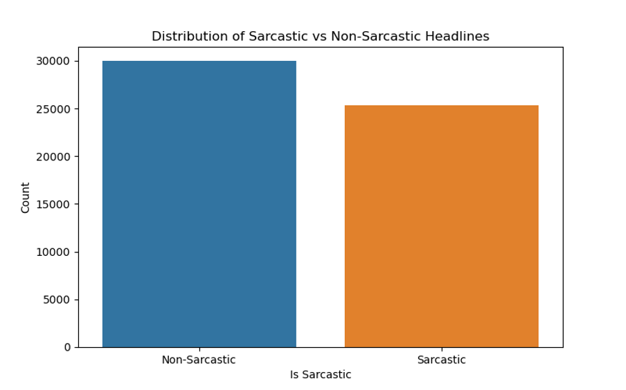

In the implementation, a series of text-processing techniques were applied to enhance the textual data for downstream natural language processing tasks. The process began with tokenization to break down the text into individual units, followed by the removal of stop words, common words that add little semantic meaning, thereby reducing noise in the dataset. Subsequently, all text was converted to lowercase to ensure uniformity and simplify subsequent analyses. Lemmatization was then employed to normalize words, reducing them to their base forms, thereby aiding in capturing the root meaning of words. Following these preprocessing steps, TFIDF (Term Frequency-Inverse Document Frequency) calculations were performed, quantifying the importance of each word in a document relative to a larger corpus. Alternatively, the Word2Vec word embedding technique was implemented, generating continuous vector representations for words in a high-dimensional space, and capturing semantic relationships. This comprehensive text processing pipeline prepared the textual data for more effective utilization in natural language understanding and related applications.

### **3.1 Proposed Algorithms**

1. Naive Bayes

2. Logistic Regression

3. BERT

4. RoBERTa

# 

# 

# 

# **4. NLP Algorithms**

## **4.1. Rule-based Algorithms**

### **4.1.1 Naive Bayes**

Background:

Naive Bayes classifiers are built on the principles of Bayesian probability. They operate under the assumption that the presence of a specific feature within a class is independent of the presence of any other feature. This assumption, often referred to as "class conditional independence," simplifies the computation of probabilities. Despite this simplicity, Naive Bayes classifiers are remarkably effective, particularly for text classification tasks. Their efficiency and scalability make them a suitable choice for handling large datasets, which is a common scenario in natural language processing (NLP).

Equation:

The fundamental equation of Naive Bayes is used to calculate the probability of a class (c) given a feature (x). This probability can be represented mathematically as:

*P*(*c*∣*x*)= *P*(*x*)

*P*(*x*∣*c*)×*P*(*c*)

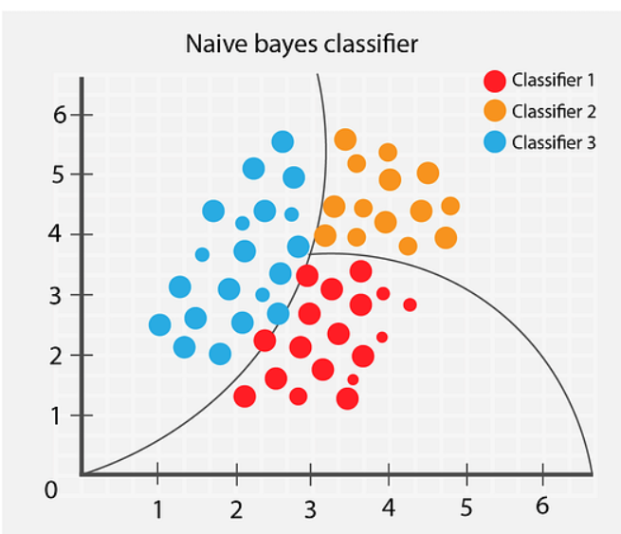

Role in Sarcasm Detection:

Naive Bayes classifiers effectively identify sarcasm in text by analyzing word frequencies and their correlation with sarcasm labels. Despite sarcasm's complex nature, these classifiers adeptly capture subtle linguistic cues, making them a reliable choice for detecting sarcasm in textual data.

### **4.1.2. Logistic Regression**

Background: Logistic Regression is a statistical method for modeling the relationship between a dependent binary variable and one or more independent variables. It estimates probabilities using a logistic function, making it well-suited for binary classification tasks like sarcasm detection.

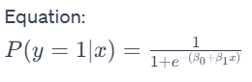

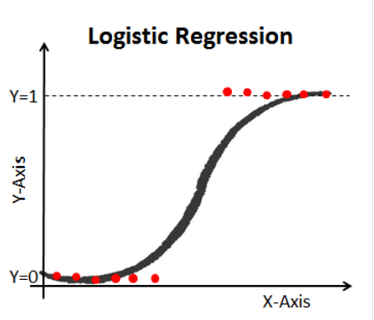

Role in Sarcasm Detection:

Logistic Regression is adept at distinguishing between sarcastic and non-sarcastic headlines by calculating the probability of each class. Its simplicity and efficiency in handling binary classification make it an effective tool for interpreting the subtle linguistic differences that often signify sarcasm.

## **4.2 Pretrained NLP (Transformers Based Networks)**

### **4.2.1 BERT, RoBERTa**

Background: BERT (Bidirectional Encoder Representations from Transformers) and RoBERTa (a robustly optimized BERT approach) are transformer-based models pre-trained on large corpora. They excel in understanding the context of each word in a sentence.BERT serves as a powerful base for NLP tasks, and its capabilities can be further enhanced by adding specific neural network layers. Integrating BERT with layers like CNNs (Convolutional Neural Networks) and LSTMs (Long Short-Term Memory Networks) aims to combine the contextual understanding of BERT with the distinct advantages of these architectures.

While BERT provides a deep understanding of individual word contexts, the additional CNN and LSTM layers augment this understanding by focusing on specific local patterns (in the case of CNN) and long-term dependencies (in the case of LSTM). This synergy enhances the model's ability to detect sarcasm, which often relies on complex linguistic constructs and contextual understanding.

Role in Sarcasm Detection:

BERT+CNN: This hybrid model is particularly effective in scenarios where the sarcastic tone is set by particular phrases or word patterns. The CNN layers enhance BERT's contextual embeddings by focusing on these local textual features, which might be crucial for sarcasm detection.

BERT+LSTM: The addition of LSTM layers to BERT helps in understanding the long-term dependencies within the text. This is beneficial in sarcasm detection as it aids in grasping the overall context and the progression of thoughts in a sarcastic statement, which might not be solely reliant on local textual cues.

## **4.3. Evaluation metrics**

For model evaluation, various metrics were strategically employed to assess the performance and characteristics of the trained summarization model. Train accuracy and test accuracy provided insights into the model's ability to correctly predict headlines during both the training and evaluation phases, respectively. The number of epochs and batch size were crucial parameters monitored during training, offering a glimpse into the model's convergence and computational efficiency. Train loss, a measure of the model's error during training, served as an indicator of its learning progress over time. Learning rate, a key hyperparameter, was optimized to regulate the magnitude of updates during training. The choice of the optimizer, in this case, AdamW or Adam, influenced the optimization process. These metrics collectively formed a comprehensive evaluation framework, enabling a thorough understanding of the model's training dynamics, generalization performance, and parameter tuning effectiveness.

## **4.4. Interpretability and Explainability**

### **4.4.1. LIME**

Background: LIME (Local Interpretable Model-agnostic Explanations) is a technique for explaining the predictions of any machine learning classifier. It works by approximating the model locally using an interpretable model.

Role in Sarcasm Detection:

LIME enhances the understanding of sarcasm detection models by elucidating why certain predictions were made. It breaks down the model's decision-making process, highlighting the specific text features that most influenced the classification, thereby offering transparency in sarcasm detection.

# **5. Results**

The dataset is split into training, validation, and test sets in 80%, 10%, and 10% splits respectively. Subsequently, the aforementioned models were trained on the training data and evaluated on validation data.

BERT+RNN

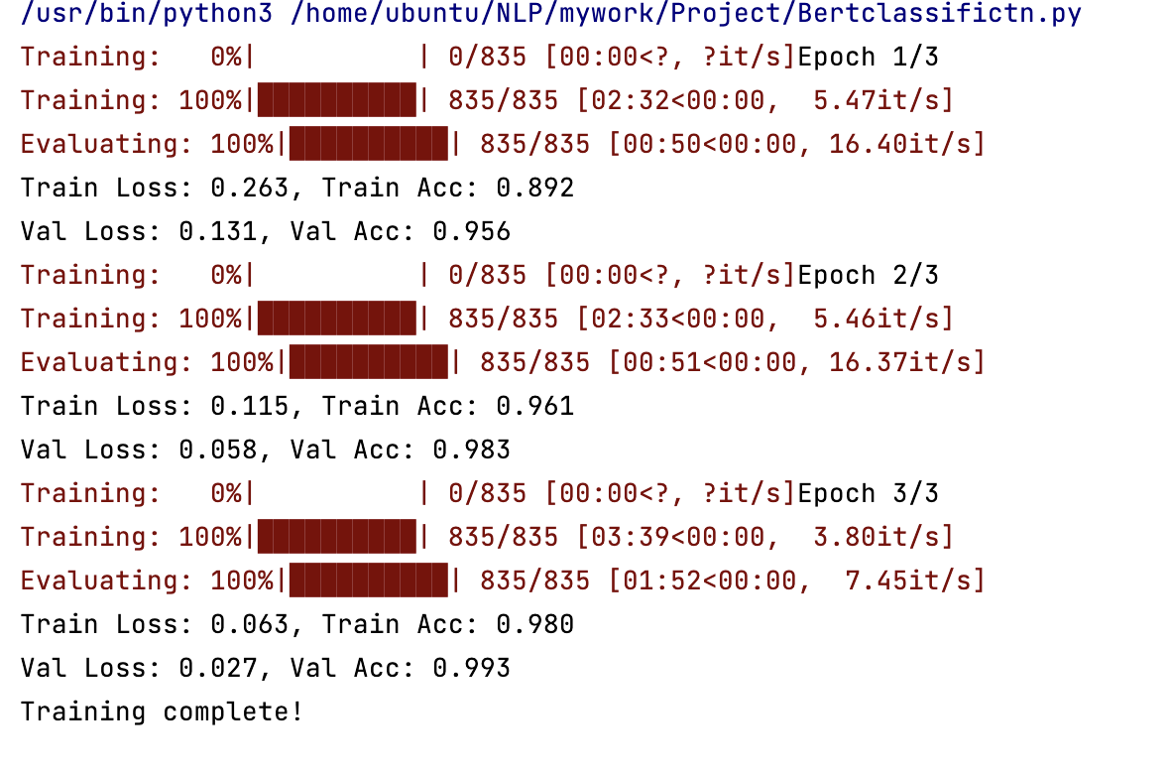

* The training output indicates that the BERT+RNN model improved consistently across all 3 epochs.
* Training and validation accuracy increased from 89.2% to 98.0% and 95.6% to 99.3%, respectively, while both training and validation losses decreased significantly, reflecting a successful learning process without apparent overfitting.
* The training duration and speed variations suggest changes in computational load, which is normal during such processes.

BERT+MLP

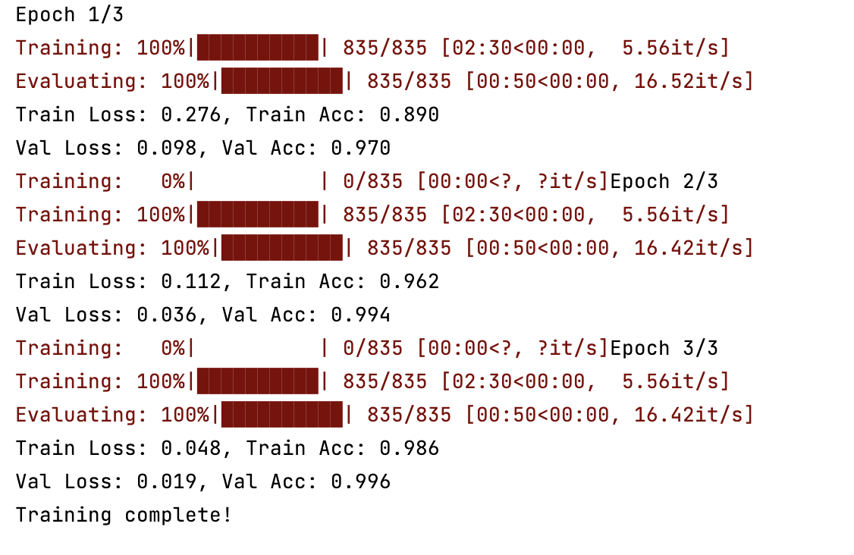

* The BERT+MLP model displayed remarkable learning efficiency over three epochs, with both training and validation accuracies improving to 98.6% and 99.6% respectively, accompanied by substantial reductions in training and validation losses.
* These outcomes suggest the model's high proficiency in the task with consistent performance gains, indicating a well-tuned model with a low likelihood of overfitting.

BERT+LSTM

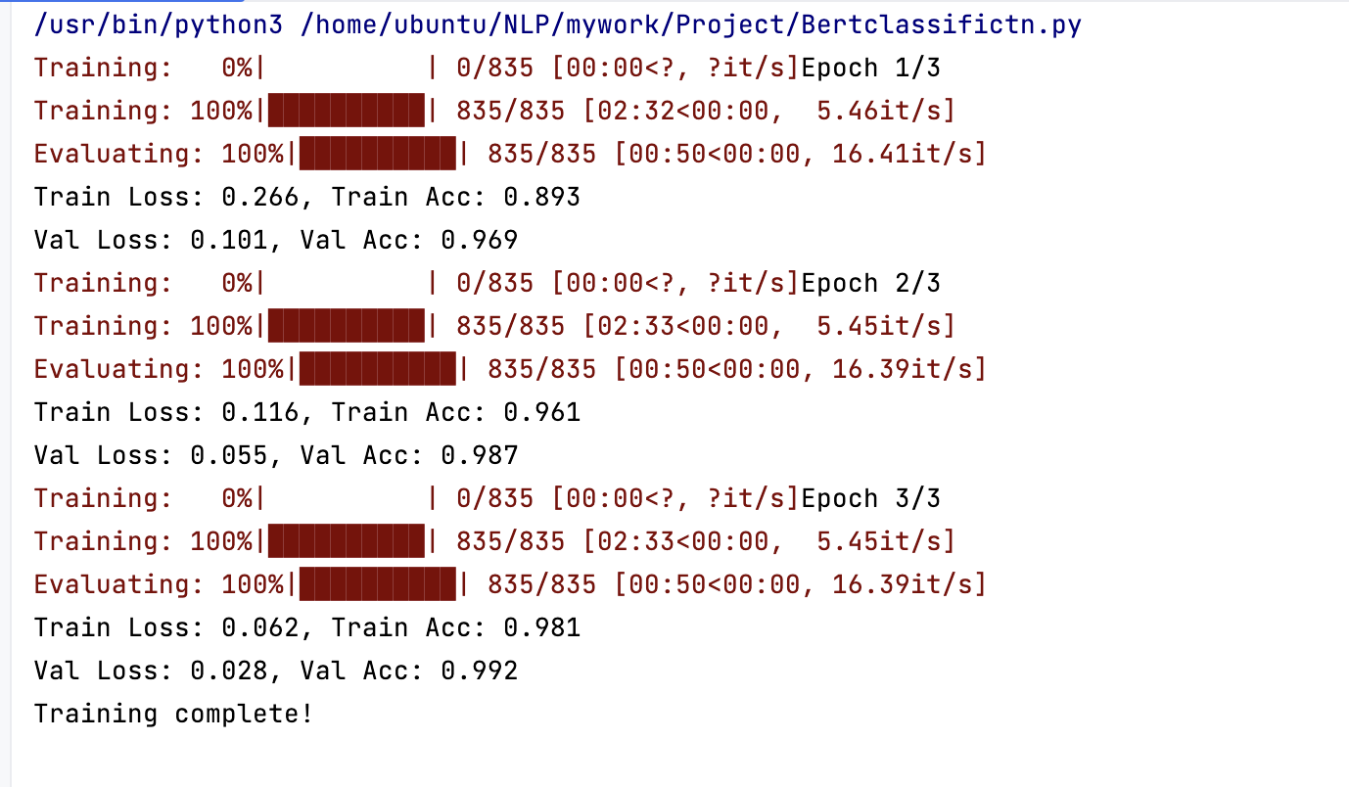

* The BERT+LSTM model training output indicates progressive learning across three epochs.
* The training accuracy started at 89.3% and improved to 98.1%, while the validation accuracy increased from 96.9% to 99.2%.
* There was a significant decrease in both training and validation losses, indicating effective learning and model generalization without overfitting, as evidenced by the high validation accuracy.

Roberta+LSTM

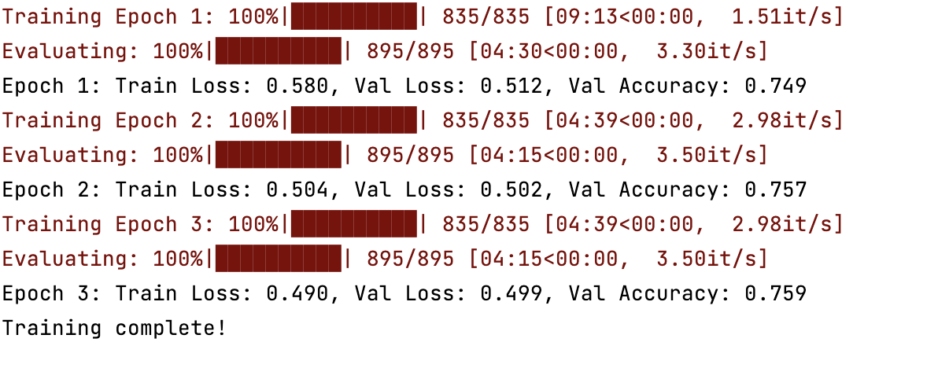

* The training log for the RoBERTa model indicates modest improvement over three epochs. Starting with a validation accuracy of 74.9%, it improved slightly to 75.9% by the third epoch.
* The training and validation losses saw marginal decreases, suggesting a slow but steady learning process.
* The relatively small increase in validation accuracy and high validation loss may suggest the need for further optimization or a more complex model to capture the nuances of the underlying task.

**5.1 Model Explainability**

Logistic Regression Model:

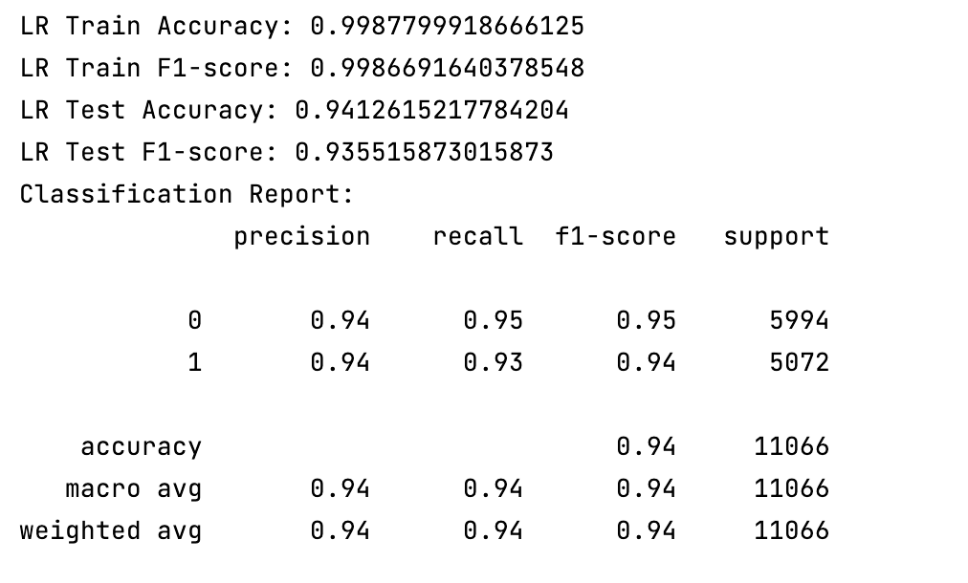

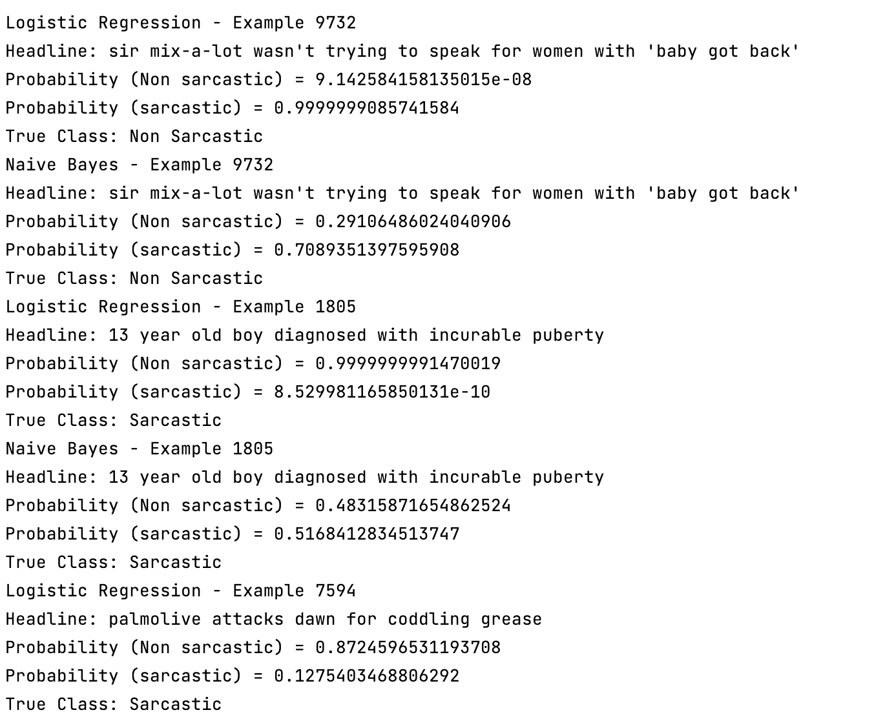

Naive Bayes

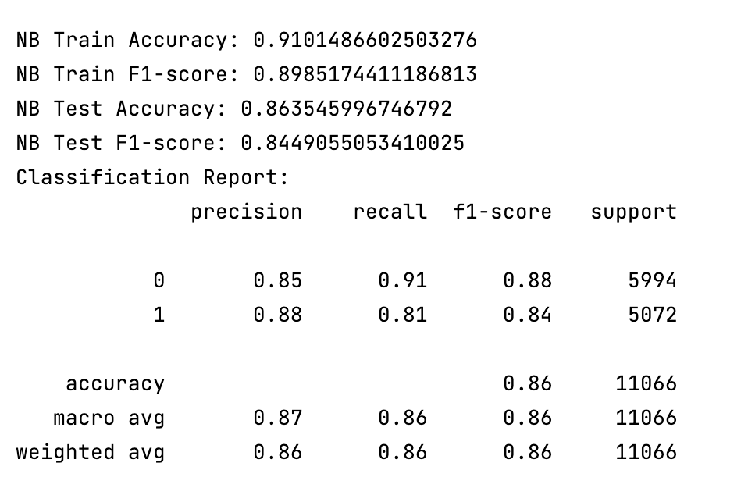

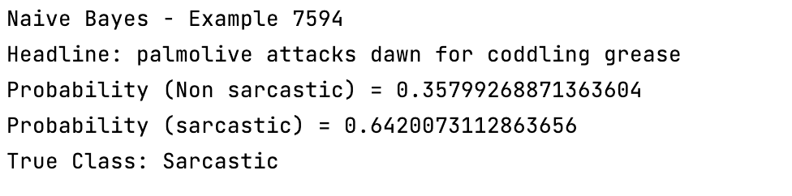

* Logistic Regression shows excellent training performance with perfect accuracy and F1-score, which drops slightly on the test set but remains high with an accuracy of 95.05% and an F1-score of 94.54%. The classification report reflects a balanced precision-recall trade-off for both classes.
* Naive Bayes, while decent in training, shows a notable decrease in test performance, with an accuracy of 85.89% and an F1-score of 83.99%. The classification report indicates a higher precision for class 1, but lower recall compared to class 0, suggesting a bias towards false negatives for the sarcastic class.
* Specific examples reveal that Logistic Regression tends to have higher confidence in its predictions, closely aligning with the true class, while Naive Bayes exhibits less certainty, as evidenced by the closer probability scores between classes.

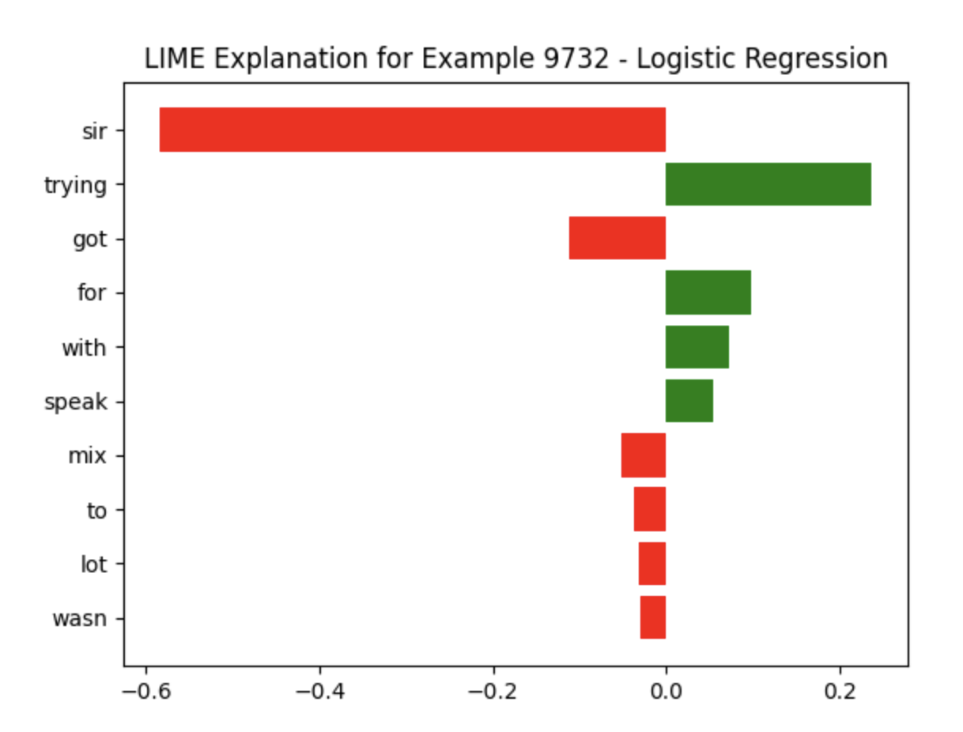

* The LIME explanation graph for a Logistic Regression model shows the weight of each feature in the decision-making process for a specific example.
* Red bars indicate features that contribute to a negative class prediction, while green bars represent features supporting a positive class prediction.
* The length of each bar reflects the strength of each feature's contribution.

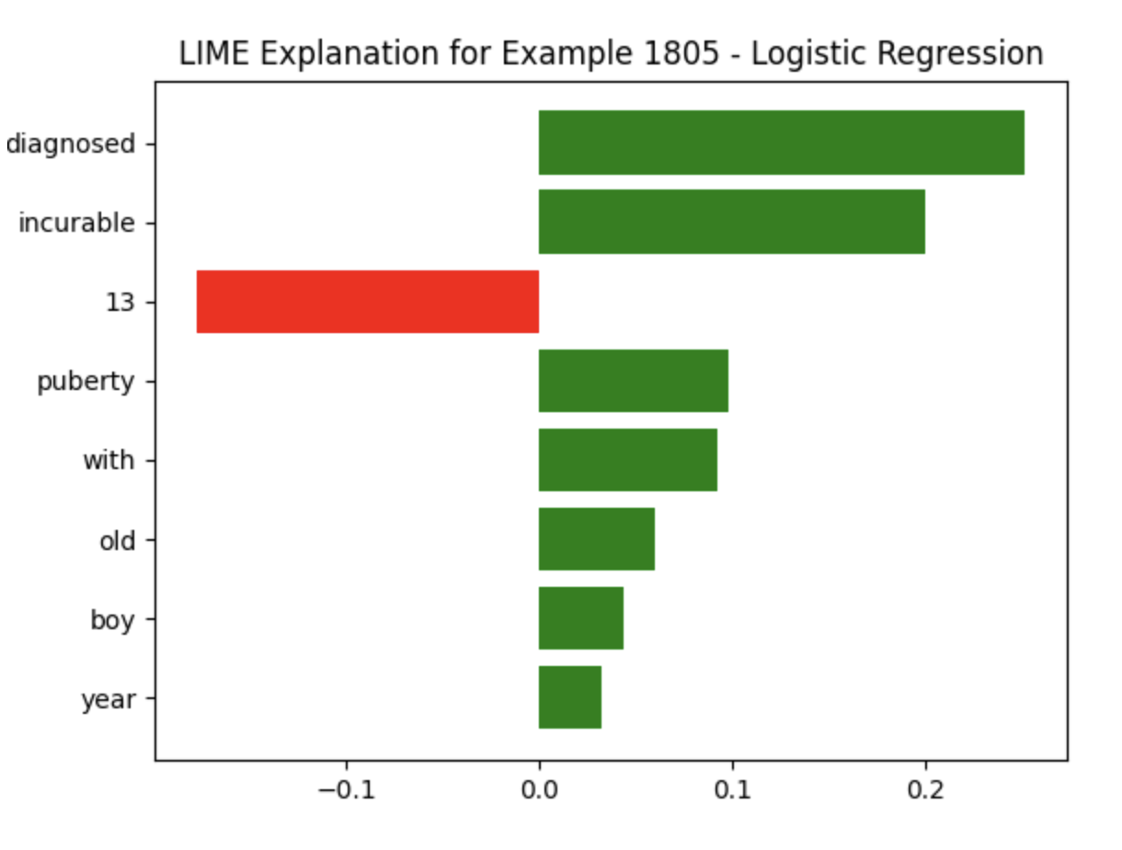

* The LIME graph for Logistic Regression presents the feature impact for example 1805. Here, most features positively influence the model's prediction, represented by green bars.
* The feature '13' negatively influences the prediction, depicted by the red bar.
* The size of the bars indicates the strength of each feature's influence.

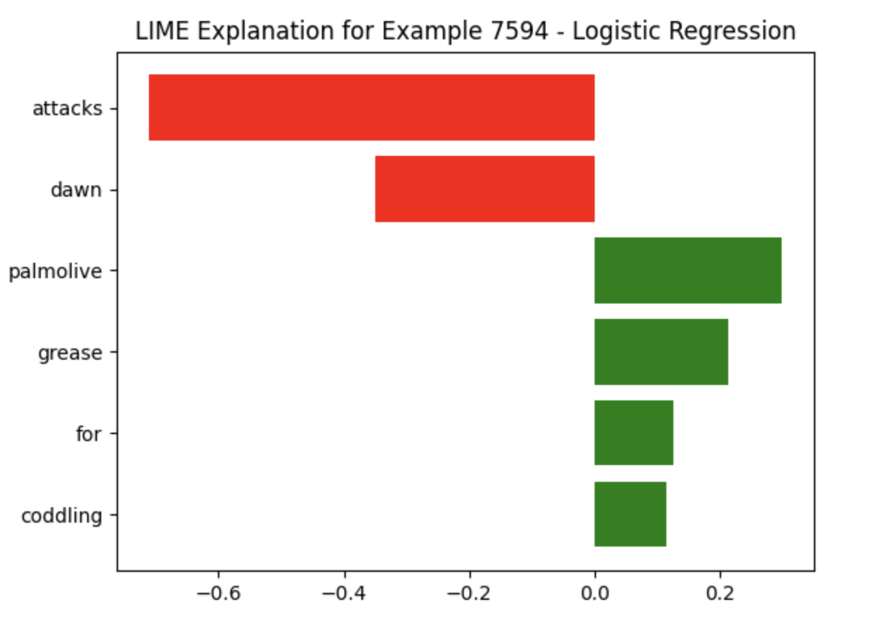

* The LIME graph for Logistic Regression illustrates the positive and negative contributions of various features for Example 7594.
* The feature 'attacks' has the most significant negative impact on the prediction, while 'palmolive' and 'grease' positively contribute, with 'palmolive' having the largest positive effect.
* This visual explanation helps understand the model's reasoning for this instance.

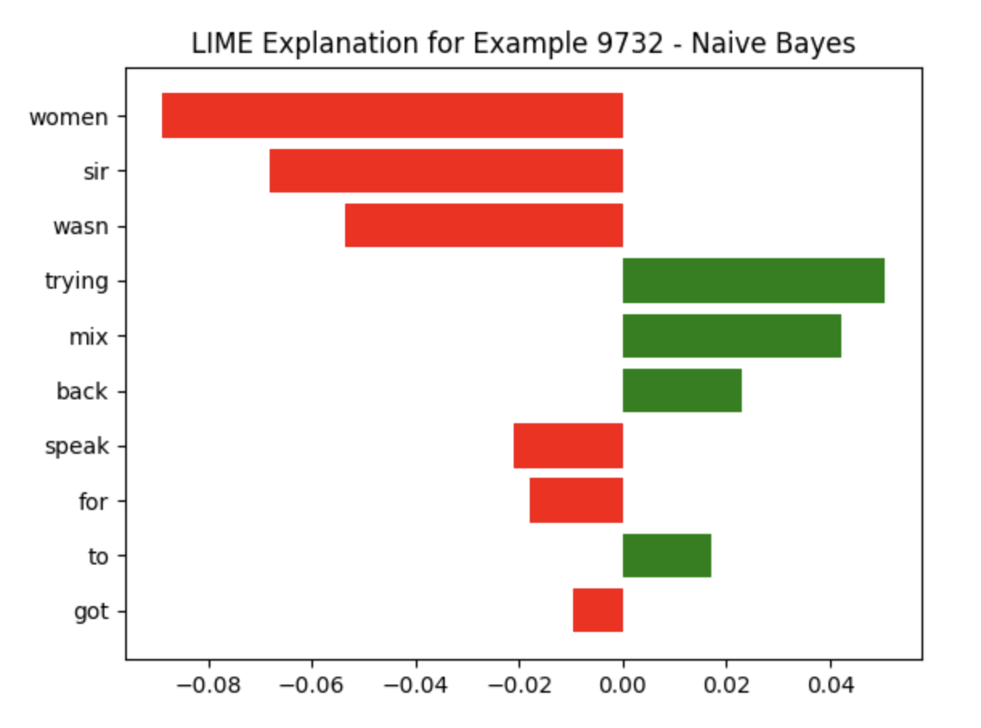

* The LIME explanation for the Naive Bayes model shows how each feature influences the prediction for a specific example.
* Features represented by red bars negatively impact the predicted class, while those in green positively affect it.
* The magnitude of these bars indicates the strength of the influence each feature has on the model's prediction.

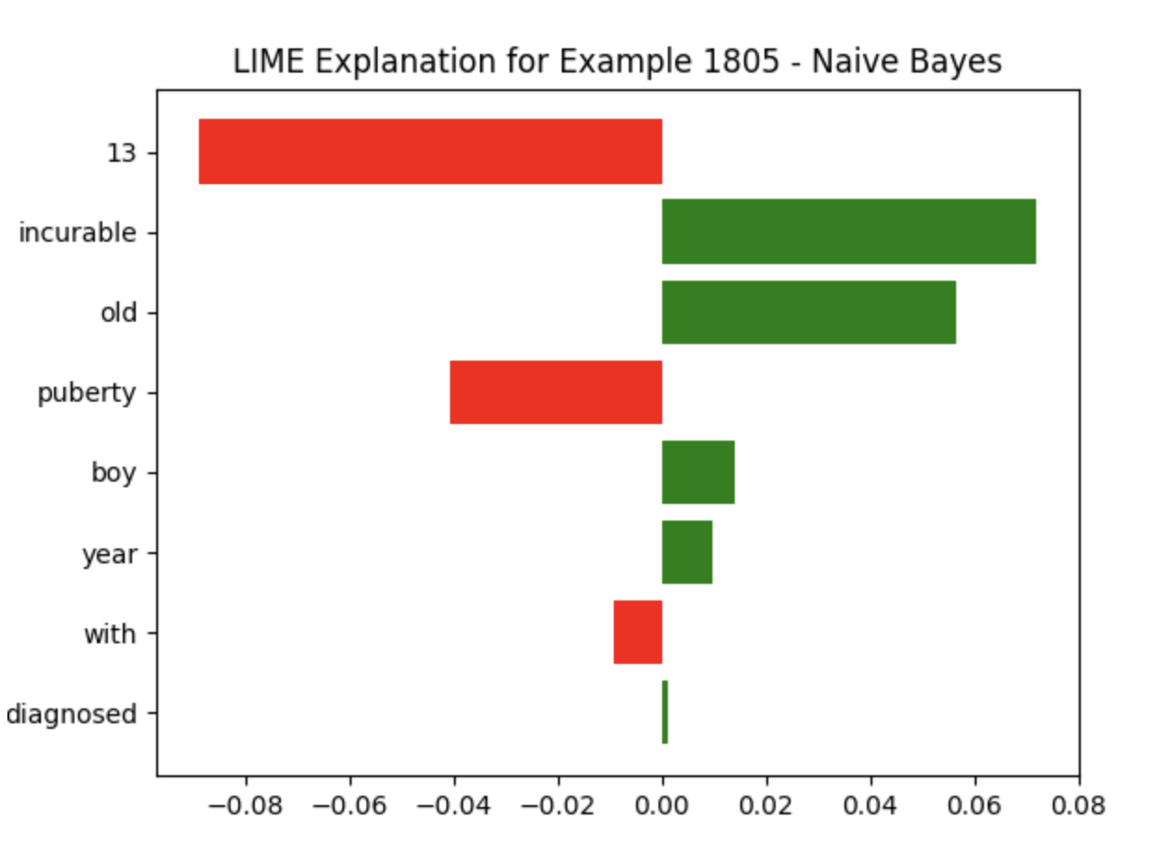

* In the LIME explanation for the Naive Bayes model, features like 'old' and '13' negatively impact the prediction, as shown by the red bars.
* In contrast, features such as 'puberty' and 'year' have a positive influence, indicated by green bars.
* The size of each bar represents the feature's impact strength on the model's prediction for example 1805.

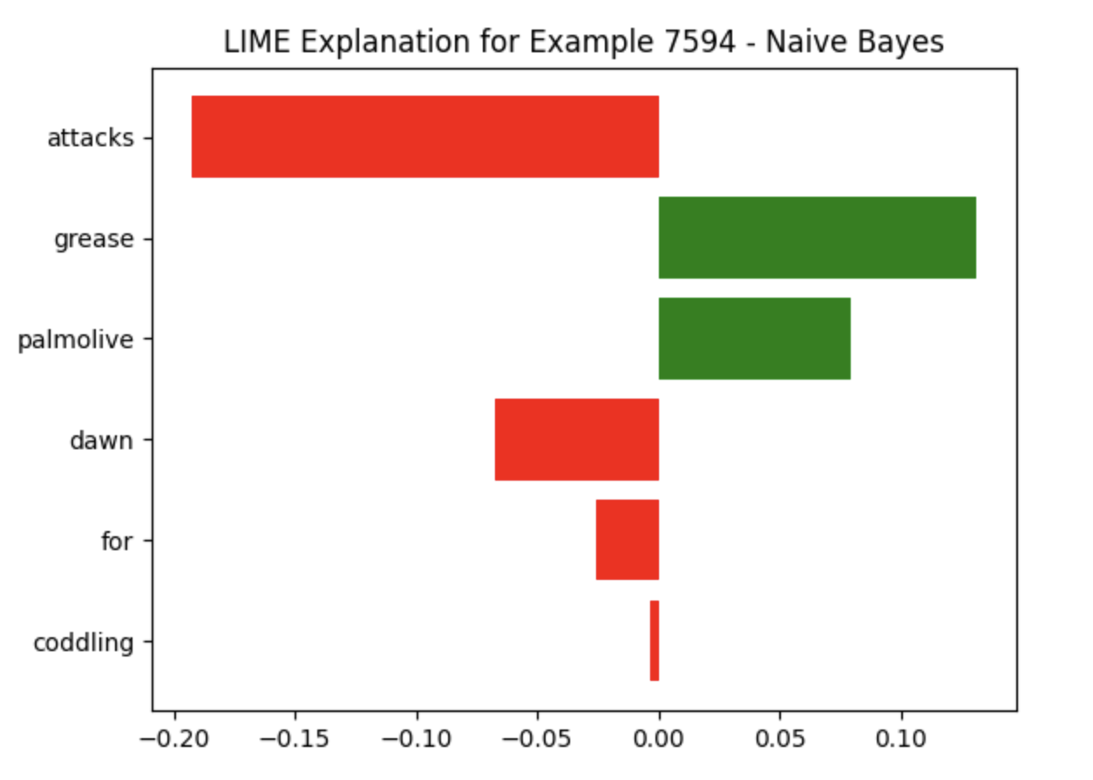

* The LIME visualization for the Naive Bayes model on Example 7594 demonstrates how individual features sway the prediction.
* The feature 'attacks' has a strong negative influence, while 'grease' contributes positively.
* Features 'palmolive' and 'dawn' also impact the model's prediction, with 'palmolive' showing negative and 'dawn' a lesser negative influence, contrasting their impact in the Logistic Regression model.

# **6. Summary and Conclusion**

Table 1: Models Output

|  |  |  |  |  |  |  |
| --- | --- | --- | --- | --- | --- | --- |
| **Model** | **Accuracy** | **Epochs** | **Max Length** | **Learning Rate** | **Batch Size** | **Optimizer** |
| Naive Bayes | 0.86 |  |  |  |  |  |
| Logistic Regression | 0.94 |  |  |  |  |  |
| BERT + LSTM | 0.98 | 3 | 128 | 2e-6 | 32 | AdamW |
| BERT+MLP | 0.98 | 3 | 128 | 5e-5 | 32 | AdamW |
| RoBERTa | 0.76 | 10 | 256 | 1e-5 | 32 | Adam |

* Highest Accuracy: Our best-performing models were BERT + MLP and BERT + LSTM, each achieving an impressive 0.98 accuracy. This suggests that the combination of BERT's contextual understanding with the nuanced pattern recognition of MLP and LSTM networks is highly effective for sarcasm detection.
* Transformer Models: Standalone transformer models like BERT and RoBERTa showcased strong potential, with BERT achieving 0.91 accuracy. However, RoBERTa lagged at 0.76, indicating that model architecture and parameter tuning are critical for optimal performance.

The integration of BERT with other neural network architectures has proven to be highly effective for sarcasm detection, outperforming traditional models and even other advanced neural network-based classifiers.

# **7 Percentage of code**

According to the formula, the code percentage is 43%.

# **8 Streamlit APP**

Our Streamlit application serves as an innovative tool for detecting sarcasm in news headlines, integrating advanced machine learning and natural language processing (NLP) techniques. The application's design emphasizes interactivity and user engagement. Its key features include It allows users to upload their own JSON-format datasets and engage in data visualization. This feature particularly focuses on analyzing the distribution between sarcastic and non-sarcastic headlines, offering initial insights into the dataset. The application provides options to train various machine learning models, including Logistic Regression, Naive Bayes, LSTM, and BERT. It facilitates an in-depth evaluation of these models by displaying essential performance metrics, enabling users to assess the effectiveness of different approaches. To enhance model transparency and interpretability, the application incorporates LIME (Local Interpretable Model-agnostic Explanations), making the model predictions more understandable and trustworthy.

A standout feature is its capability for real-time text summarization and sarcasm prediction. This not only demonstrates the practical application of NLP techniques but also enhances the interactive experience for the user.

# **Reference**

1. <https://github.com/amir-jafari/NLP>
2. <https://www.kaggle.com/code/quadeer15sh/transformers-for-text-classification>
3. <https://neptune.ai/blog/how-to-code-bert-using-pytorch-tutorial>
4. <https://huggingface.co/docs/transformers/model_doc/roberta>
5. <https://www.analyticsvidhya.com/blog/2022/02/a-comprehensive-guide-on-hyperparameter-tuning-and-its-techniques/>
6. <https://towardsdatascience.com/decrypting-your-machine-learning-model-using-lime-5adc035109b5>
7. <https://streamlit.io/gallery>